Rich picture

[diagram billag\Rich picture.jpg](diagram%20billag/Rich%20picture.jpg)

Deployment diagram

[diagram billag\deployment dirgram.drawio.pdf](diagram%20billag/deployment%20dirgram.drawio.pdf)

Use-case diagram

[diagram billag\Use-case dirgram.pdf](diagram%20billag/Use-case%20dirgram.pdf)

Login – SSD diagram

[diagram billag\SSD and SD diagram\1) Login\Login - SSD dirgram.drawio.pdf](diagram%20billag/SSD%20and%20SD%20diagram/1)%20Login/Login%20-%20SSD%20dirgram.drawio.pdf)

Login – SD diagram

[diagram billag\SSD and SD diagram\1) Login\Login - SD dirgram.drawio.pdf](diagram%20billag/SSD%20and%20SD%20diagram/1)%20Login/Login%20-%20SD%20dirgram.drawio.pdf)

CreateNewBooking – SSD diagram

[diagram billag\SSD and SD diagram\2) Create new booking\CreateNewBooking - SSD dirgram.drawio.pdf](diagram%20billag/SSD%20and%20SD%20diagram/2)%20Create%20new%20booking/CreateNewBooking%20-%20SSD%20dirgram.drawio.pdf)

CreateNewBooking -SD diagram

[diagram billag\SSD and SD diagram\2) Create new booking\CreateNewBooking - SD dirgram.drawio.pdf](diagram%20billag/SSD%20and%20SD%20diagram/2)%20Create%20new%20booking/CreateNewBooking%20-%20SD%20dirgram.drawio.pdf)

ScanRFIDCard – SSD diagram

[diagram billag\SSD and SD diagram\3) Scan RFID card\Scan RFID card - SSD dirgram.drawio.pdf](diagram%20billag/SSD%20and%20SD%20diagram/3)%20Scan%20RFID%20card/Scan%20RFID%20card%20-%20SSD%20dirgram.drawio.pdf)

ScanRFIDCard – SD diagram

[diagram billag\SSD and SD diagram\3) Scan RFID card\Scan RFID card - SD dirgram.drawio.pdf](diagram%20billag/SSD%20and%20SD%20diagram/3)%20Scan%20RFID%20card/Scan%20RFID%20card%20-%20SD%20dirgram.drawio.pdf)

Booking api – class diagram

[diagram billag\Class diagram\Api booking Class diagram.drawio.pdf](diagram%20billag/Class%20diagram/Api%20booking%20Class%20diagram.drawio.pdf)

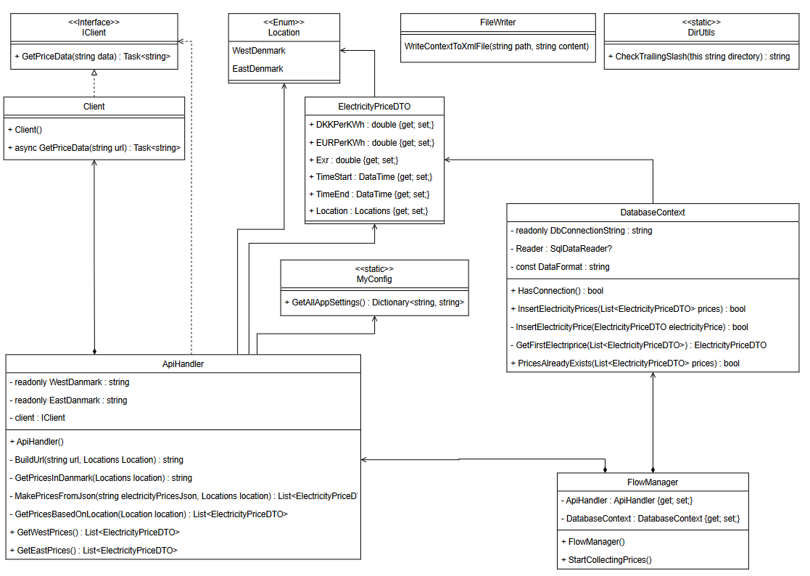Client api – class diagram

[diagram billag\Class diagram\Api client Class dirgram.drawio.pdf](diagram%20billag/Class%20diagram/Api%20client%20Class%20dirgram.drawio.pdf)

ER-diagram

[diagram billag\Er_diagram_VaskeriDb.drawio.pdf](diagram%20billag/Er_diagram_VaskeriDb.drawio.pdf)

Angular: component diagram

[diagram billag\Augular - component diagram.drawio.pdf](diagram%20billag/Augular%20-%20component%20diagram.drawio.pdf)

Arduino – circuit diagram

[diagram billag\Arduino circuit dirgram.png](diagram%20billag/Arduino%20circuit%20dirgram.png)

Arduino – Flow diagram

[diagram billag\arduino flow dirgram.drawio.pdf](diagram%20billag/arduino%20flow%20dirgram.drawio.pdf)

Login – Wireframe

[diagram billag\Wireframe\Login.png](diagram%20billag/Wireframe/Login.png)

Make booking – Wireframe

[diagram billag\Wireframe\Make booking.png](diagram%20billag/Wireframe/Make%20booking.png)

Se booking – Wireframe

[diagram billag\Wireframe\Se booking.jpg](diagram%20billag/Wireframe/Se%20booking.jpg)